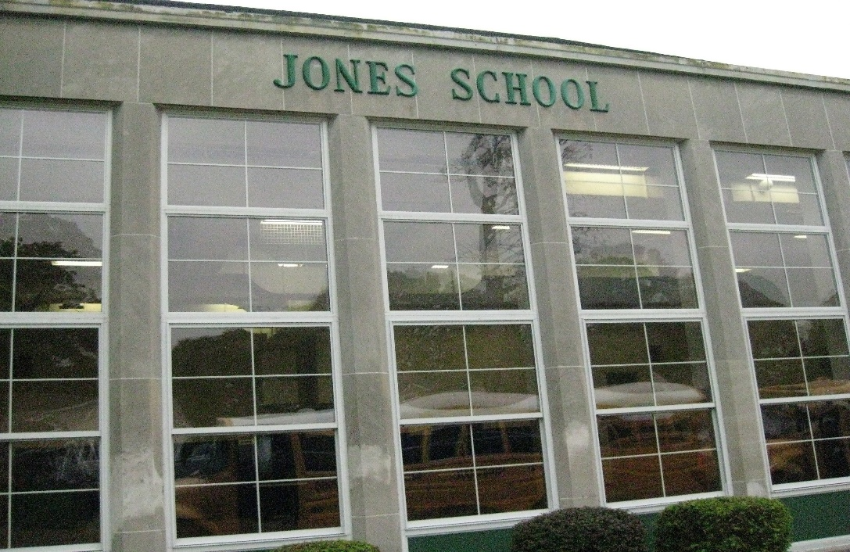

MINIMUM CAPACITY :-

The Minumum intake capacity

of students is between 300-620

children

LIBRARY :-

The Libarary is Available.

CANTEEN:-

The Canteen Facility is Available.

BOARDING :-

No availablility of boarding.

SPORTS :-

There are different categories

sports available.

Girls Volleyball

Boys Volleyball

Football

|  |  |  |
| --- | --- | --- |
| HUGH R JONES ELEMENTARY SCHOOL  UTICA - SCHOOL |  |  |
|  |  |  |
| School Detail :- Hugh R. Jones Elementary School, in partnership with its students, parents, and community, offers each student the opportunity to achieve a superior education, by providing quality instruction and challenging learning experiences, in a safe and orderly environment, which will foster life-long learning and responsible citizenship. |  |